Exploratory Data Analysis on Superstore Sales Data
Task 1 Report

1. Objective
The goal of this task was to perform a complete, industry-style exploratory data analysis on a real sales dataset. The analysis covers data cleaning, missing-value handling, descriptive statistics, outlier detection, correlation analysis and a set of visualizations, ending with a clear summary of what the data says about the business.

2. Dataset
The dataset used is Superstore Sales: 8,399 rows and 21 columns covering four years of trading, from January 2009 to December 2012. Each row is one product line inside a customer order rather than a whole order, so the 8,399 rows belong to 5,496 unique orders placed by 795 customers across 1,263 distinct products.
The columns cover order details (date, priority, quantity, ship mode, ship date), money columns (sales, discount, profit, unit price, shipping cost), customer details (name, province, region, segment) and product details (category, sub-category, container, base margin).

3. Methodology
The analysis was carried out in a single Jupyter notebook, structured in numbered sections so each step is easy to follow and reproduce. The sequence was:
- Load the data and inspect its shape, data types, duplicates and unique counts.
- Clean the data: convert the date columns to real datetime values, derive a Shipping Delay column, and validate that no record has a negative delay, zero sales or zero quantity.
- Analyse missing values by count and percentage, visualize them, and fill the affected column.
- Produce descriptive statistics for numeric columns and value counts for categorical columns.
- Detect outliers with the IQR rule and decide how to handle them.
- Run univariate, bivariate, correlation and time-series analysis.
- Summarize the findings and record improvements for the next iteration.

4. Data Cleaning and Missing Values
Both date columns loaded as plain text and were converted with an explicit format. A Shipping Delay column was derived as the number of days between order and shipment, which ranges from 0 to 92 days. Validation checks confirmed that no order ships before it was placed, and that there are no zero or negative sales or quantities, so no rows had to be dropped as invalid. There were also no fully duplicated rows.
Only one column contained missing data: Product Base Margin, with 63 missing values, which is 0.75 percent of the dataset. Because the gap is small and the column is numeric, the rows were kept and the gaps were filled with the median margin of the same product category. This is safer than a single global median and keeps every sale in the analysis. After this step the dataset contained zero missing values.
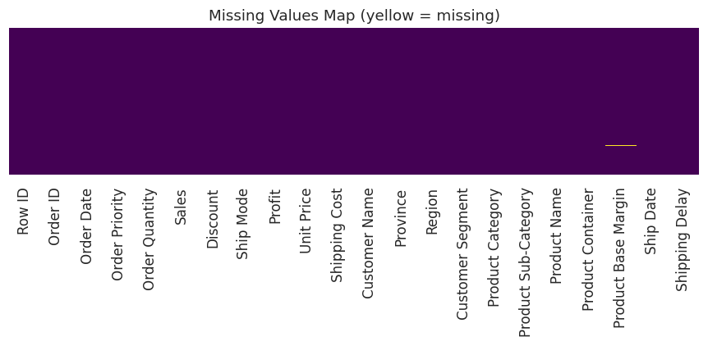
Figure 1: Missing-value map across all columns

5. Descriptive Statistics
The summary statistics reveal a heavily right-skewed sales distribution. The average sale is 1,775.88 while the median is only 449.42, which means most orders are small and a handful of very large orders pull the average upward. Profit runs from a loss of 14,140.70 to large gains.
Measure | Value
Total sales | 14,915,600.82
Total profit | 1,521,767.98
Average sale | 1,775.88
Median sale | 449.42
Loss-making order lines | 4,264 (50.8%)
Date range | 1 Jan 2009 to 30 Dec 2012

The categorical columns are clean, with no odd spellings or stray categories. Office Supplies is the largest product category by row count (4,610), followed by Technology (2,065) and Furniture (1,724).

6. Outlier Analysis
Outliers were checked using the IQR rule, flagging any value below Q1 minus 1.5 times the IQR or above Q3 plus 1.5 times the IQR.
Column | Outliers | Percent
Profit | 1,704 | 20.29%
Shipping Delay | 1,143 | 13.61%
Sales | 1,042 | 12.41%
Shipping Cost | 972 | 11.57%
Unit Price | 848 | 10.10%
Discount | 3 | 0.04%
Order Quantity | 0 | 0.00%
Product Base Margin | 0 | 0.00%

The decision was to keep these outliers rather than remove them. A 10,000 order or a 14,000 loss is a genuine business event, not a data-entry error, and deleting them would hide exactly the transactions the business most needs to understand. Order Quantity and Discount are well behaved with almost no outliers.
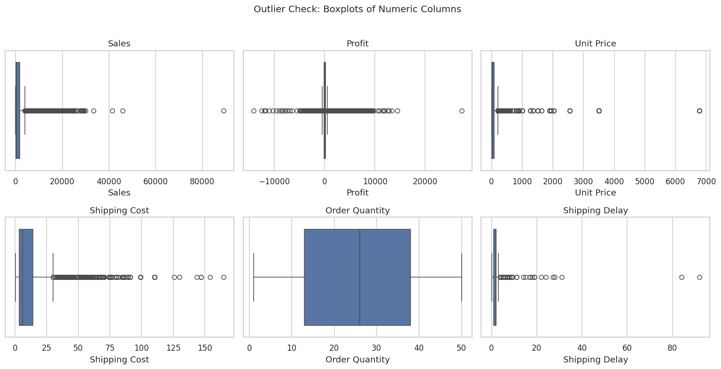
Figure 2: Boxplots of the main numeric columns

7. Visual Analysis
Eight visualizations were produced. The most informative are shown below.
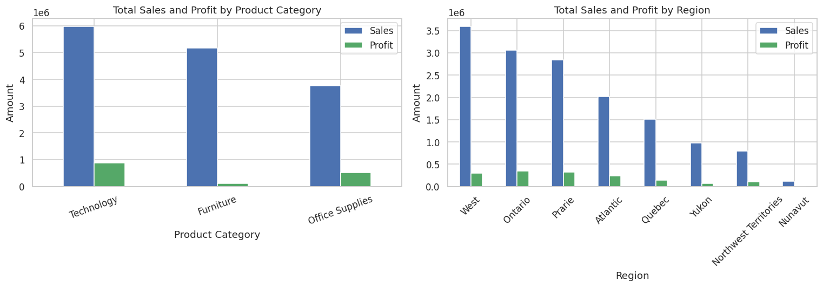
Figure 3: Total sales and profit by product category and by region
Technology brings in the most profit (886,314) despite Office Supplies having more than twice as many order lines. Furniture sells almost as much as Technology, 5,178,591 against 5,984,248, but returns only 117,433 in profit, roughly a seventh as much.
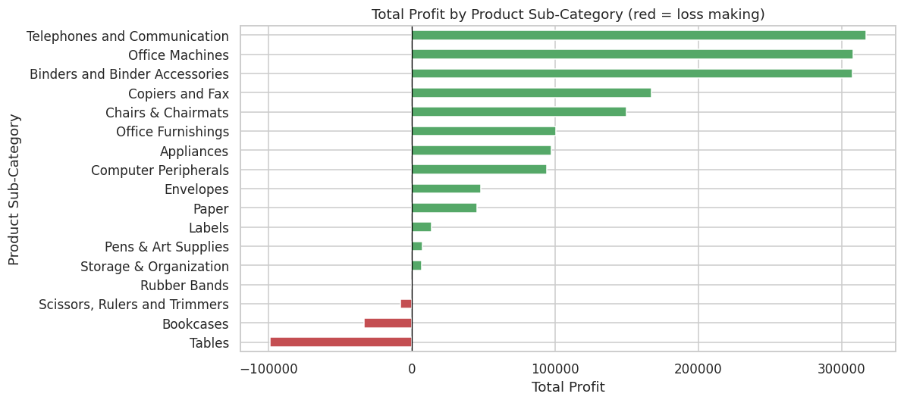
Figure 4: Total profit by product sub-category, red bars are loss making
Profit is very unevenly spread across sub-categories. Four sub-categories lose money overall, and Tables is the worst by a wide margin at a loss of 99,062, followed by Bookcases at a loss of 33,582.
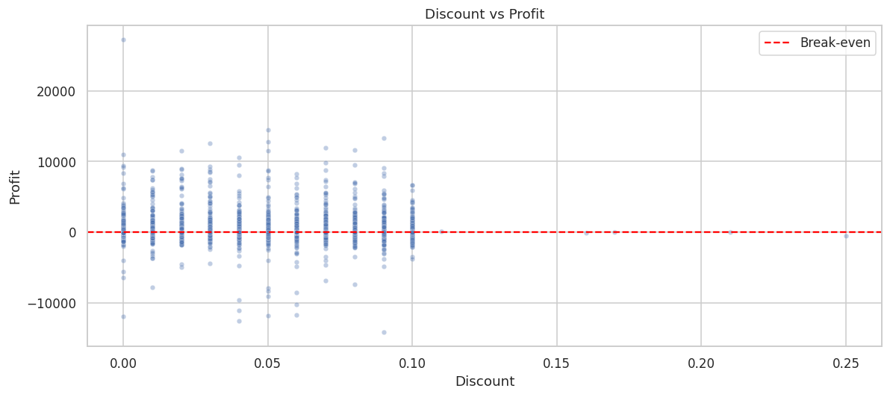
Figure 5: Discount against profit, with the break-even line marked
Grouping the orders into discount bands makes the pattern explicit: average profit falls from 230.72 in the lowest band to a loss in the highest, while the share of loss-making orders rises from 47.2 percent to 56.0 percent. Discounting is a direct lever on profitability, not a neutral marketing cost.

8. Correlation Analysis
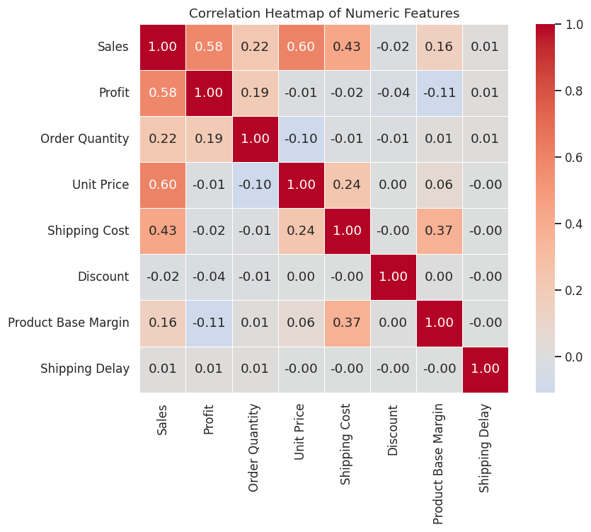
Figure 6: Correlation heatmap of the numeric features
Sales correlates most strongly with Unit Price (0.60) and Shipping Cost (0.44): expensive items produce bigger sale values and cost more to ship. Importantly, Sales correlates with Profit at only 0.58, which is moderate rather than strong. A big sale does not automatically mean a big profit. Discount shows a weak negative correlation with profit, matching the scatter plot. No pair of features is near-perfectly correlated, so there is no redundant column to drop.

9. Time Trend
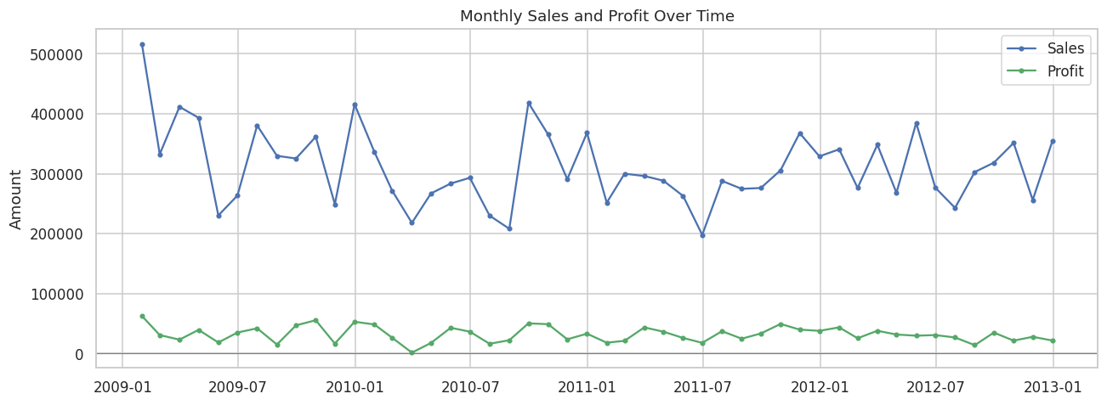
Figure 7: Monthly sales and profit across the four-year period
Monthly sales are volatile with no clean seasonal pattern. Yearly sales drift down from 4,209,139 in 2009 to 3,719,964 in 2012, and yearly profit slides from 434,539 to 341,902 over the same period. Profit stays close to the zero line all the way through, even in high-sales months. That gap between the two lines is the clearest visual statement of the core problem: revenue is healthy, margin is not.

10. Key Findings
- The data was almost clean. Only Product Base Margin had gaps, 63 values or 0.75 percent, filled with the category median. No duplicate rows and no invalid dates, quantities or sales.
- Money columns are heavily skewed and full of statistical outliers, which were kept on purpose because large orders and large losses are real business events.
- Roughly half of all order lines lose money, 4,264 rows or 50.8 percent. This is the headline finding.
- Technology is the most profitable category. Office Supplies has the most volume but thinner returns, and Furniture sells well while returning very little.
- Four sub-categories lose money overall, Tables worst of all.
- Discount is directly tied to profitability: higher discount bands show lower average profit and a higher share of losses.
- Sales does not predict profit well, correlating at only 0.58, so revenue targets alone are a poor measure of business health.
- Sales and profit are volatile month to month with no strong seasonality, and both drift slightly downward across the four years.

11. Key Lessons and Improvements for the Next Iteration
- Filling missing margins with a category median is quick but crude. Filling at the sub-category or product level would be more accurate.
- Keeping outliers is the right call for a business report, but a modelling task should also test a capped or log-transformed version of Sales.
- This analysis works at the order-line level. Rolling it up to whole orders or to customers would answer different and equally useful questions, such as which customers are unprofitable overall.
- The dataset has no cost-of-goods column, so the reason behind each loss can only be inferred from discount and shipping cost. Adding cost data would make the profit analysis conclusive.
- The finding that half of all orders lose money leads directly into Task 2, which builds a model to predict whether an order will be profitable.

